The Garage at Point Venture

JUNIOR
ACADEMY

AGES 5-18

- Enroll in academy class

- Choose add-on programs

- Watch your golfer grow

6 LEVELS | 12 SUBJECTS | 72 OBJECTIVES
PROGRESSING JUNIORS TOWARDS PAR OR BETTER ON AND OFF THE COURSE
The Garage at Point Venture Junior Academy uses the Operation 36® framework to structure the program. It consists of Coaching, Playing, and Training programs and is designed to teach golfers to play the game from a hole out perspective.
Each golfer will be issued a profile in the Operation 36® Mobile App to track progress through a 6 level curriculum that is designed to set appropriate objectives and challenge each student towards shooting par or better (score of 36) for 9 holes.

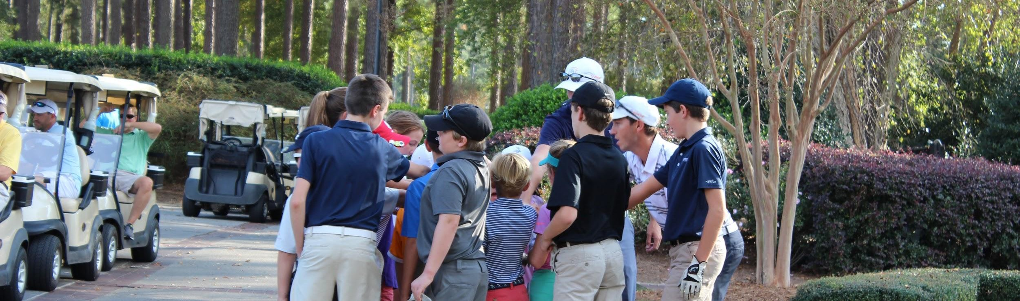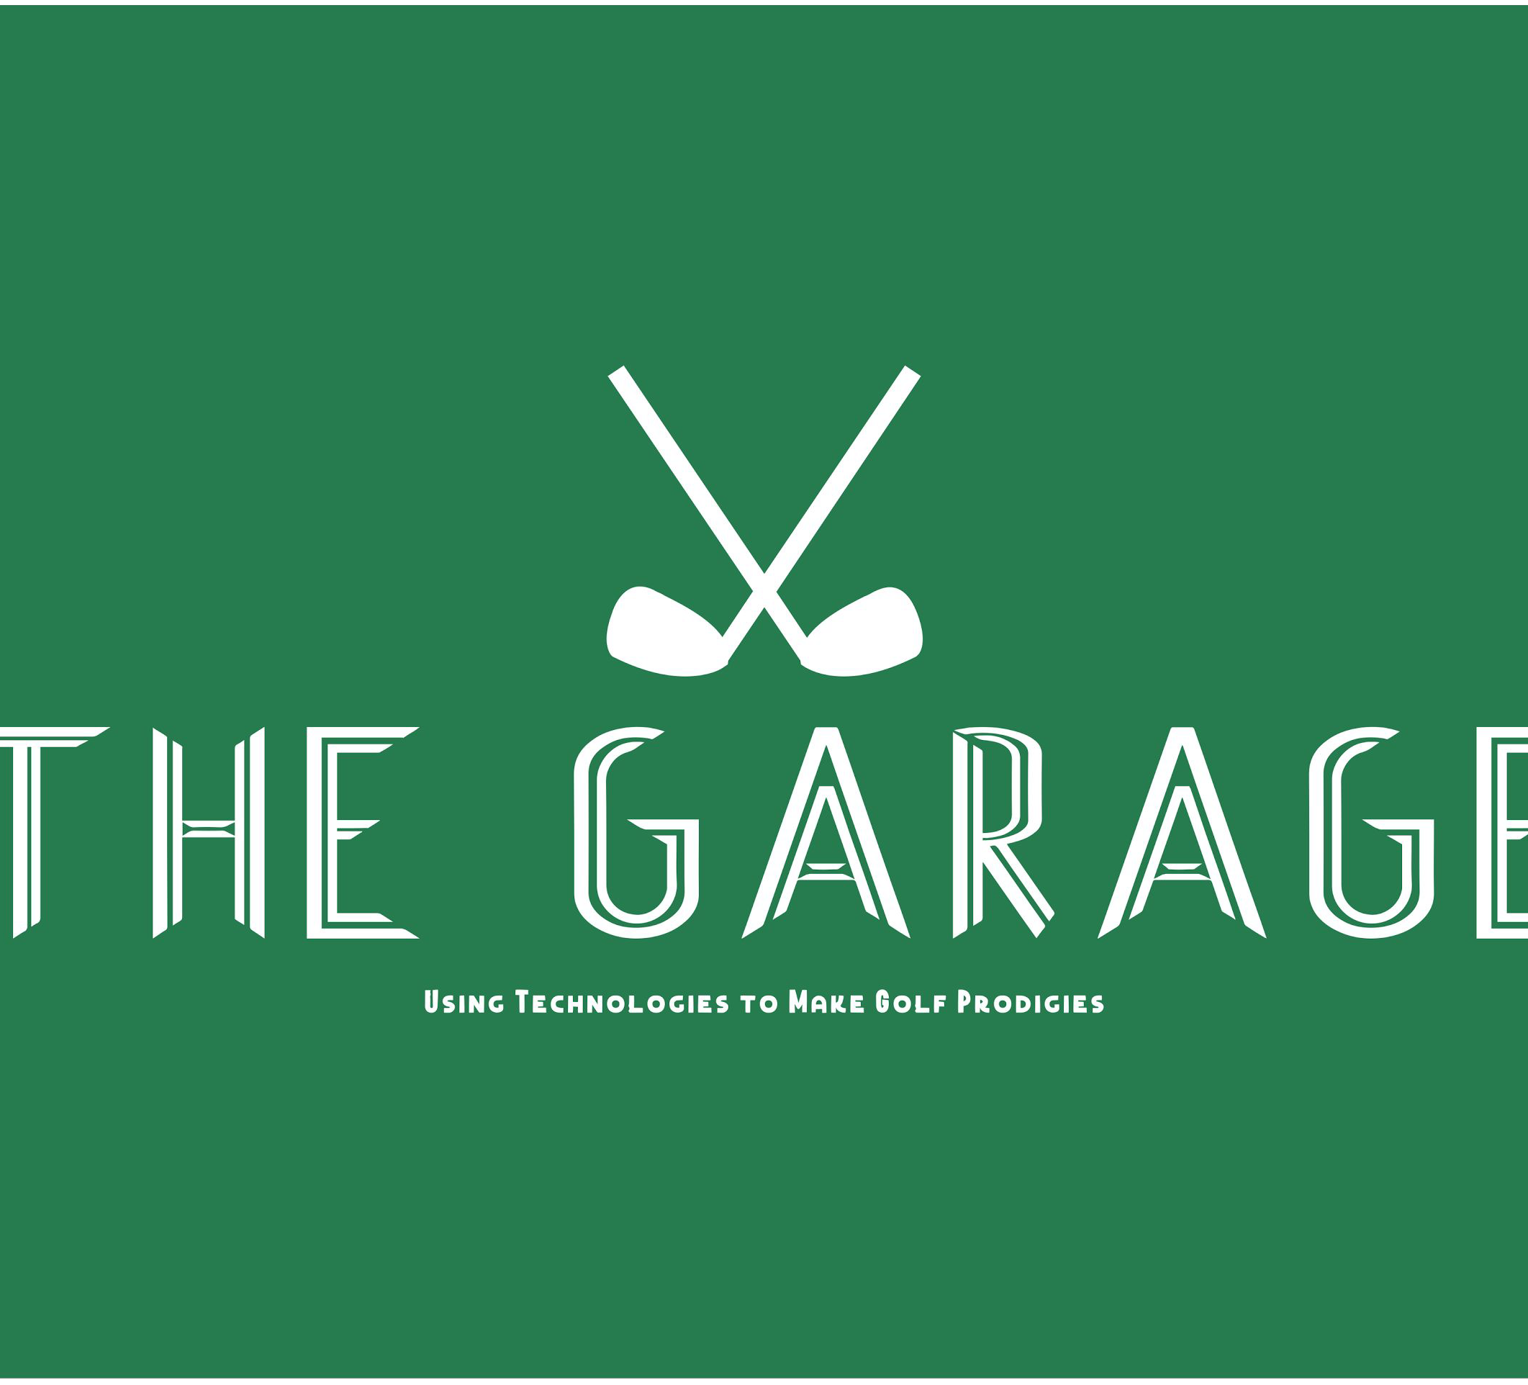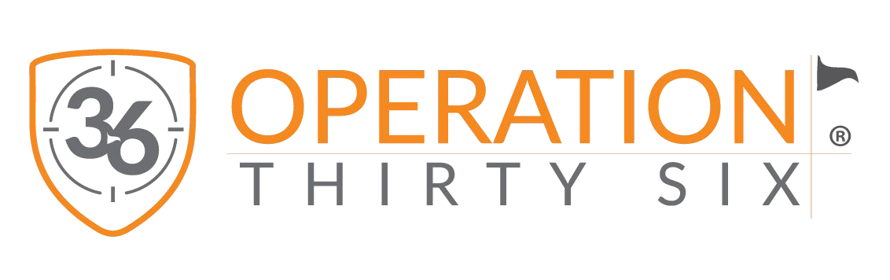

ENROLL TODAY
JUSTIN ORBIN, PGA
Voted “One of America’s Best Golf Instructors”

For more information please email
Justin at JustinOrbin@PointVenture..com

To learn more about the Operation 36® Program & Curriculum please visit www.Operation36.Golf

ACADEMY CLASSES
LEARN THE GAME
Juniors will learn the game in a weekly group class where our coaches will progress students through the 6 level Operation 36® curriculum.

OPERATION 36® MATCHES
TEST YOUR SKILLS
The Operation 36® Matches challenge golfers to shoot the score of 36 for 9 holes from 6 different yardage divisions on the course.

SUPERVISED PRACTICE
TEST YOUR SKILLS
Golfers can accelerate skill development by training alongside a coach who sets up a structured and efficient practice session.

THE GARAGE TUITION & SCHEDULE

ACADEMY PACKAGE
$49/Mo
$147 per semester

(12) Academy Classes
PLAYER PACKAGE
$99/Mo
$296 per semester

(12) Academy Classes

(4) Operation 36 Matches
MINI-TOUR PACKAGE
$149/Mo
$448 per semester

(12) Academy Classes

(4) Operation 36 Matches

(12) Supervised Practice
TOUR PACKAGE
$199/Mo
$597 per semester

(12) Academy Classes

(4) Operation 36 Matches

(12) Supervised Practice

(4) 30 Min Private Lessons

ADDITIONAL SERVICES & FEES
FAMILY DISCOUNTS All accounts are billed on the 1st for

Enrollment & Tech Fees - $99/student Op 36 Progress Bag Tag - $30/tag
30 Minute Private Lesson - $49
10% off 2nd Juniors Tuition 20% Off 3rd Juniors Tuition 30% Off 4th Juniors Tuition
the upcoming month. Payments are due on the first of the month and can be made via the Academy Web Portal. Any past due accounts may suspend enrollment.

ACADEMY CLASS SCHEDULE
We split our academy into semesters. Once enrolled in a class you hold your spot for the entire semester as well as priority for future semesters. If you would like to drop enrollment your spot may be filled by wait-listed students.
SEMESTER 1 SEMESTER 2 SEMESTER 3 SEMESTER 4
7/9/22 – 9/17/22 10/1/22 – 12/17/22
1/22/22 – 3/19/22
4/2/22 –6/25/22
8:1 Student to Coach

Explore the dates in your juniors age group and contact coach for availability. This will be the date and time your junior attends each week throughout the entire semester and works through the Operation 36® Curriculum.

Saturdays 2-2:30PM

OPERATION 36® MATCHES

AGE 5-18
The Operation 36® Matches provide a great experience for juniors to challenge themselves and test their skills on the course.
SUPERVISED PRACTICE

8:1 Student to Coach
Supervised Practice runs weekly for the entire semester

AGES 5-18

SATURDAYS (3:30-5:30 PM) 4 Times a Semester
Saturdays
2:30-3:30PM

