The Garage at Point Venture

ADULT
ACADEMY

AGES 18+

- Enroll in academy class

- Choose add-on programs

- Watch your golfer grow

6 LEVELS | 12 SUBJECTS | 72 OBJECTIVES
PROGRESSING ADULTS TOWARDS PAR OR BETTER ON AND OFF THE COURSE
The Garage at Point Venture Adult Academy uses the Operation 36® framework to structure the program. It consists of Coaching, Playing, and Training programs and is designed to teach golfers to play the game from a hole out perspective.
Each golfer will be issued a profile in the Operation 36® Mobile App to track progress through a 6 level curriculum that is designed to set appropriate objectives and challenge each student towards shooting par or better (score of 36) for 9 holes.

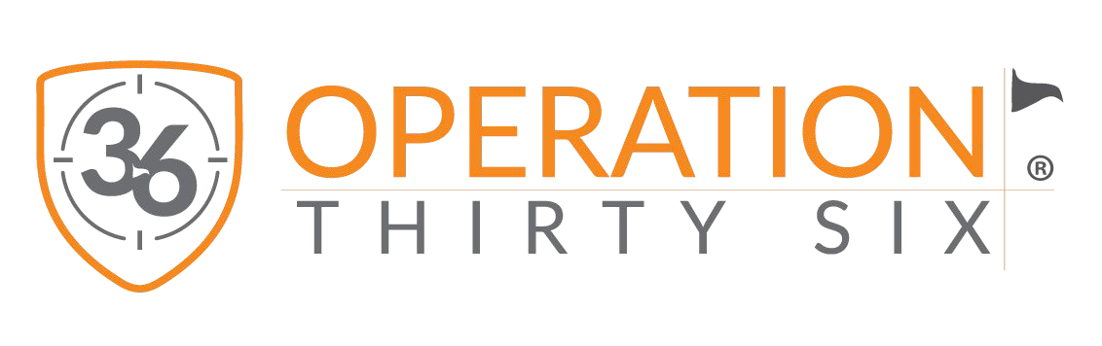

ENROLL TODAY
JUSTIN ORBIN, PGA
Voted “One of America’s Best Golf Instructors”

For more information please email
Justin at JustinOrbin@PointVenture..com

To learn more about the Operation 36® Program & Curriculum please visit www.Operation36.Golf

ACADEMY CLASSES
LEARN THE GAME
Adults will learn the game in a weekly group class where our coaches will progress students through the 6 level Operation 36® curriculum.

OPERATION 36® MATCHES
TEST YOUR SKILLS
The Operation 36® Matches challenge golfers to shoot the score of 36 for 9 holes from 6 different yardage divisions on the course.

SUPERVISED PRACTICE
TEST YOUR SKILLS
Golfers can accelerate skill development by training alongside a coach who sets up a structured and efficient practice session.

THE GARAGE TUITION & SCHEDULE

ACADEMY PACKAGE
$49/Mo
$98 per semester

(10) Academy Classes
PLAYER PACKAGE
$99/Mo
$198 per semester

(10) Academy Classes

(4) Operation 36 Matches
MINI-TOUR PACKAGE
$149/Mo
$298 per semester

(10) Academy Classes

(4) Operation 36 Matches

(10) Supervised Practice
TOUR PACKAGE
$199/Mo
$398 per semester

(10) Academy Classes

(4) Operation 36 Matches

(10) Supervised Practice

(4) 30 Min Private Lessons

ADDITIONAL SERVICES & FEES
FAMILY DISCOUNTS MONTHLY PAYMENTS
Enrollment & Tech Fees - $99/student Op 36 Progress Bag Tag - $30/tag
30 Minute Private Lesson - $49
10% off 2nd Adult Tuition
Payments are due on the 15th of the month. Any past due accounts may suspend enrollment.

ACADEMY CLASS SCHEDULE
We split our academy into semesters. Once enrolled in a class you hold your spot for the entire semester as well as priority for future semesters. If you would like to drop enrollment your spot may be filled by wait-listed students.
SEMESTER 1 SEMESTER 2 SEMESTER 3 SEMESTER 4
7/9/22 – 9/17/22 10/1/22 – 12/17/22
1/22/22 – 3/19/22
4/2/22 – 6/25/22
12:1 Student to Coach

Explore the dates and contact coach for availability. This will be the date and time you attend each week throughout the entire semester and work through the Operation 36® Curriculum.

Saturdays 9:30-10am

OPERATION 36® MATCHES

AGE 18+
The Operation 36® Matches provide a great experience for adults to challenge themselves and test their skills on the course.
SUPERVISED PRACTICE

8:1 Student to Coach
Supervised Practice runs weekly for the entire semester

AGES 18+

SATURDAYS (11AM-1PM)
4 Times during the Semester
Saturdays 10:00-11:00am

